**SMART TRAFFIC LIGHTS**

BACHELOR OF COMPUTER ENGINEERING

by

Karan Shah, 19102038

Nidhi Heniya, 19102041

Nikita Joshi, 19102033

Jainam Zaveri 20202007

Guide

Prof. Rushikesh Nikam



Department of Computer Engineering

A. P. SHAH INSTITUTE OF TECHNOLOGY, THANE

2022-2023



A. P. SHAH INSTITUTE OF TECHNOLOGY, THANE

CERTIFICATE

This is to certify that the project entitled “Smart Traffic Lights” is a bonafide work of **“Karan Shah(19102038), Nidhi Heniya(19102041), Nikita Joshi(19102033), Jainam Zaveri(20202007)”** submitted to the University of Mumbai in partial fulfilment of the requirement for the award of the degree of **Bachelor of Engineering** in **Computer Engineering**

**________________________________ __________________________________**

Guide Project Coordinator

Prof. Rushikesh Nikam Prof. Rushikesh Nikam

_______________________ ______________________

Head of Department Principal

Prof. Sachin Malave Dr. Uttam Kolekar

Date:

 A. P. SHAH INSTITUTE OF TECHNOLOGY, THANE

**Project Report Approval for B.E.**

This project report for Sem-VII entitled ***Smart Traffic Lights*** by ***Karan Shah(19102038), Nidhi Heniya(19102041), Nikita Joshi(19102033), Jainam Zaveri(20202007)*** is approved for the degree of ***Bachelor of Engineering*** in ***Computer Engineering***, ***2022-23***.

Examiner Name Signature

1. ___________________________

2. ___________________________

Date:

Place:

**Declaration**

We declare that this written submission represents my ideas in my own words and where others' ideas or words have been included, I have adequately cited and referenced the original sources. I also declare that I have adhered to all principles of academic honesty and integrity and have not misrepresented or fabricated or falsified any idea/data/fact/source in my submission. I understand that any violation of the above will be cause for disciplinary action by the Institute and can also evoke penal action from the sources which have thus not been properly cited or from whom proper permission has not been taken when needed.

(Karan Shah 19102038)

(Nidhi Heniya 19102041)

(Nikita Joshi 19102033)

(Jainam Zaveri 20202007)

Date:

**Abstract**

The current traffic management system requires immediate improvement because it is inefficient due to the unpredictable nature of traffic density trends across the day. The system's timers have a fixed time duration for shifting traffic flow between various directions. This causes vehicles to wait for a longer period of time, even though traffic density is minimal. As a fix, the signal timer can be coded to differ depending on the variance of traffic density. This can significantly reduce traffic congestion, in addition to offering numerous other benefits.

The proposed system focuses on four-way intersections with square traffic signals and aims to enhance the existing traffic management system. To process and estimate actual traffic on the roads, the model employs image processing and machine learning. The system will then calculate the duration for every road before enabling the signal.

The system is an intelligent resemblance of a traditional traffic cop who has successfully made better decisions to ensure the smooth flow of traffic at the intersection.

**CONTENTS**

1. Introduction 1
2. Literature Survey 5
3. Limitation of Existing System 9
4. Problem Statement, Objectives and Scope 11

4.1 Problem Statement 11

4.2 Objectives 11

4.3 Scope 11

1. Proposed System 13

5.1 Proposed System Overview 13

5.2 Design details 19

5.3 Methodology 20

1. Experimental Setup 21
2. Project Plan 0
3. Expected Outcome 0

References 0

**LIST OF FIGURES**

5.1.1 Architecture Diagram 0

5.1.2 Data Flow Diagram (level 0) 0

5.1.3 Data Flow Diagram (level 1) 0

5.1.4 Sequence Diagram 0

5.1.5 Activity Diagram 0

5.2.1 Implementation Output 0

5.2.2 Implementation Output 0

**LIST OF TABLES**

2.1 Literature review Table 0

**Abbreviation**

|  |  |
| --- | --- |
| *YOLO* | You Only Look Once |
| *AI* | Artificial Intelligence |
| *TST* | Traffic Signal Timer |
| *ATLTC* | Adaptive Traffic Light Timer Control |
| *UML* | Unified Modeling Language |

**CHAPTER 1**

**Introduction**

Traffic lights have been used as signalling tools to regulate traffic flows at road intersections, crosswalks, rail trains, and other locations since 1912. Traffic signals use three universally recognised colours: green, yellow, and red. The green signal allows traffic to proceed in the indicated direction, while the yellow signal alerts drivers to a brief stop and the red signal eventually indicates a complete stop. Traffic signals have resulted as an efficient way to manage traffic of vehicles.

Nowadays, many countries suffer from traffic congestion issues, which disrupt city transportation systems and cause serious problems. Despite the replacement of traffic officers and flagmen by automated traffic systems, optimizing heavy traffic jams remains a major challenge, especially with multiple junction nodes. The rapid increase in the number of automobiles and the ever-increasing number of road users is not accompanied by promoted infrastructure with adequate resources. Construction of new roads, implementation of flyovers and bypass roads, creation of rings, and road rehabilitation were all partial solutions. However, due to the involvement of numerous parameters, the traffic problem is extremely complicated. First, traffic flow is affected by the time of day, with peak hours generally occurring in the morning and afternoon; by the days of the week, with weekends revealing minimal load while Mondays and Fridays generally revealing dense traffic oriented from cities to their outskirts and in reverse direction; and by the time of year, with holidays and summer being the most affected.

Second, the current traffic light system is hard coded, with light transition time slots that are fixed on a regular basis and do not depend on real-time traffic flow. The third point is concerned with the condition of one light at an intersection, which influences traffic flow at adjacent intersections. Furthermore, the traditional traffic system does not account for accidents, roadworks, and broken-down vehicles, that exacerbate traffic congestion Furthermore, a critical issue is related to the smooth movement of objects through intersections of Priority emergency vehicles, such as ambulances, rescue vehicles, the fire department, the police, and VIPs could become entangled in the crowd Finally, there are the pedestrians who cross the street.

The lanes also have an impact on the traffic system. It is widely acknowledged today that Indian cities are becoming increasingly congested and unliveable. With a rapidly growing population, traffic on the roads is increasing proportionally. This can now be controlled using a variety of methods and modern technology. Indian cities have seen various types of traffic management systems, right from manually traffic police officers controlling traffic being present on site themselves to modern IT-based smart traffic management systems. Traffic police officers gesture signs that every vehicle driver has to follow, failing to do so, the officer has completed right to fine the driver. Generally, in this type of management system physical presence of the central controlling person is essential, considering the physical presence is essential, it is equally risky in case any physical accident takes place. On the other hand, IT-based signal systems are considered to be more effective. As mentioned above, traffic signals have three lights, basically red, green and yellow lights. If the signal is green, traffic flow is allowed to move, if the signal is yellow, traffic is supposed to go slow and get ready for complete halt.

Then comes another transition of making traffic lights more modern and effective and smarter. Making traffic lights, Smart Traffic Lights, these systems consist of various components which makes these signals multi-purpose and completely automatic. These smart traffic lights include cameras, certain sensors which collects live data from signal areas and uses it for certain purpose.

Similarly, this project is based on the concept of Smart Traffic Lights. Smart traffic lights is a multi-purpose traffic signal lights system, which manages and controls the flow of traffic automatically on the basis of live traffic and has an anti-honking module which resets the traffic signal if the sound pollution at that signal reaches certain decibel level. Now, this is done by using external components like camera for capturing live traffic on the basis of which the timer will change and a sound sensor which will capture the sound level of honks. This collected data is processed by model and decision of setting timer is made.

Smart Traffic Lights is created keeping the vision of building an automated smart signal which will utilize data efficiently and reduce traffic issues in metro cities.

**CHAPTER 2**

**Literature Survey**

With the increasing number of vehicles in urban areas, many road networks are facing problems with the capacity drop of roads and the corresponding Level of Service. Many traffic-related issues occur because of traffic control systems on intersections that use fixed signal timers. They repeat the same phase sequence and its duration with no changes. Increased demand for road capacity also increases the need for new solutions for traffic control that can be found in the field of Intelligent Transport Systems.

Mihir Gandhi et. al The objective was to utilize live images from the cameras at traffic junctions for traffic density calculation using image processing and AI.

Followed steps used in this paper were:

1)Capturing Image

2)Detecting Image

3)Processing Image

4)Calculating and Modifying Signal timer Based on results

A traffic system was proposed by authors named Smart control of Traffic Light Using Artificial Intelligence. Most of the system findings point to a 23% improvement over the essentially current traffic system in terms of the quantity of cars crossing the intersection, which is literally quite big and generally quite significant.

They usually held the opinion that doing so efficiently reduces unwanted delays, traffic, and waiting times, all of which contributed to a decrease in fuel consumption and pollution, which is unquestionably quite substantial [1].

Reference [2] suggests one of the most efficient object identification algorithms and one that incorporates many of the most cutting-edge concepts being developed in the field of computer vision research is the YOLO (You Only Look Once) real-time object detection algorithm.

The capacity of autonomous car systems to identify objects is essential. It is a field of computer vision that is rapidly developing and doing incredibly well compared to just a few years back.

“Overview of YOLO object Detection Algorithm.” Date Sep 25 2018, By Authors ODSc-Open Data Science. The Objective was to Understand the concept and implementation of YOLO (You Only Look Once). Model is Trained as Follows:

Input Image **->** CNN Layer **->** Max Pool Layer **->** CNN Layer -> Max Pool Layer **->** Output

Authors Indicates that One of the more significant classical issues in computer vision is sort of object detection. A convolution neural network (CNN) called YOLO (you only look once) is used to identify objects in real time, which is kind of crucial.

Contrary to popular assumption, the YOLO method applies a pretty much identical neural network to the rather whole image before splitting it into smaller portions and making predictions.

Because it can operate in near-real time and achieves unquestionably high accuracy, YOLO is often highly quick and well-liked. Which makes the system imperative.

Siddharth Srivastava et.al Due to the unpredictable traffic density patterns throughout the day, India’s metro cities currently use an ineffective traffic control system (TCS). The duration of time that the traffic signal timers use to move traffic between different directions is fixed. Because of this, even when there is very little traffic, vehicles must wait for a very long time. The issue of traffic congestion can be considerably lessened if the traffic signal timer (TST) can be set to be adjusted with the continuously shifting traffic density.

The objective was to design an intelligent traffic signal control system algorithm with the use of sensing devices and image processing systems. This autonomous control system works on principles of,

1)Image Capturing

2)Image Processing

3)Receiving Output and comparing with predefined Threshold

Authors of Adaptive Traffic Light Timer Control (ATLTC) recommended a system or approach for intelligent traffic signal control that, for all practical purposes, heavily depends on image processing and sensing technology.

For all intents and purposes, the recorded photographs were processed using the image processing toolbox. The controller frequently needed to for all intents and purposes run the designed algorithm on it in order to especially specifically adjust the time period of the traffic signal timer, or so they for all intents and purposes believed.

Bilal Ghazal et.al Many nations nowadays experience severe traffic congestion issues that have an impact on the city’s transportation infrastructure. The optimization of the huge traffic jam is still a significant problem to be confronted, especially with several junction nodes, even though automatic traffic systems have taken the place of traffic police and flagmen.

There aren’t adequate infrastructures with enough resources to keep up with the rapidly rising number of cars and the steadily increasing number of road users. By building additional highways, executing flyovers and bypass roads, building rings, and undertaking road rehabilitation, partial answers were provided. However, the complexity of the traffic issue stems from the multiple parameters that are involved.

The Objective was to realize smooth motion of cars in the transportation routes.

Proposed System works on:

1)Data Collection

2)Pre-processing

3)Result Calculations and Comparisons

4)Output

Authors of Smart Traffic Light Control System proposed system A traffic light controller controls the traffic lights at a junction of essentially monodirectional roads in a smart traffic system. Using IR sensors placed on either side of the highways, the system can determine the density of the traffic.

Accordingly, the period allotted for the green light will either be shortened to avoid needless waiting when there aren’t any cars at all on the opposite route or extended to accommodate big flows of cars in the event of a traffic congestion. Contrary to popular assumption, the system is mainly supplemented by a portable controller for the emergency vehicles backed up in traffic.

Arif A. Bookseller et.al The number of vehicles on the road today is expanding along with the purchasing power of the average person, resulting in high traffic that is challenging to manage and keep safe. This issue is particularly acute and dangerous for pedestrians in major cities like “Pune,” “Bangaluru,” and “Mumbai.” Traffic growth in this area is not linear as in comparison to the construction of bridges, intersections, and other forms of infrastructure. Most people find it challenging.

In established cities, it can be difficult or impossible to expand or modify them. A new building needs its own time under any restrictions. Options for traffic control are available to facilitate smooth traffic flow at intersections. In addition to already-existing “one-way” restrictions and “conventional traffic monitoring and management,” the department system for autonomous signaling.

Objective of proposed system was to improve efficiency of existing automatic traffic signaling system.

Proposed System works on:

1)Data Collection

2)Image Processing

3)Calculations

4)Result

The authors of this study showed how the intersection’s current traffic control system can be improved. The system was made more effective with the inclusion of artificial vision intelligence, using image processing techniques to calculate time each time for each road before allowing the signal. The system was intelligent enough to use GSM at a specific crossroads to provide priority to approved emergency vehicles.

This model resembles a conventional traffic policeman who always makes the right choice and regulates traffic. Today’s unexpected traffic growth is causing major issues in major cities. The suggested solution featured adaptive signal regulating based on image processing. Depending on the volume of traffic, the timing can be automatically determined for each time change.

The proposed system may incorporate automated signaling in addition to a typical operating model. With the use of a digital camera installed on a motor for the system’s rotation to face lanes and feel the traffic on the road, artificial vision is provided for the system.

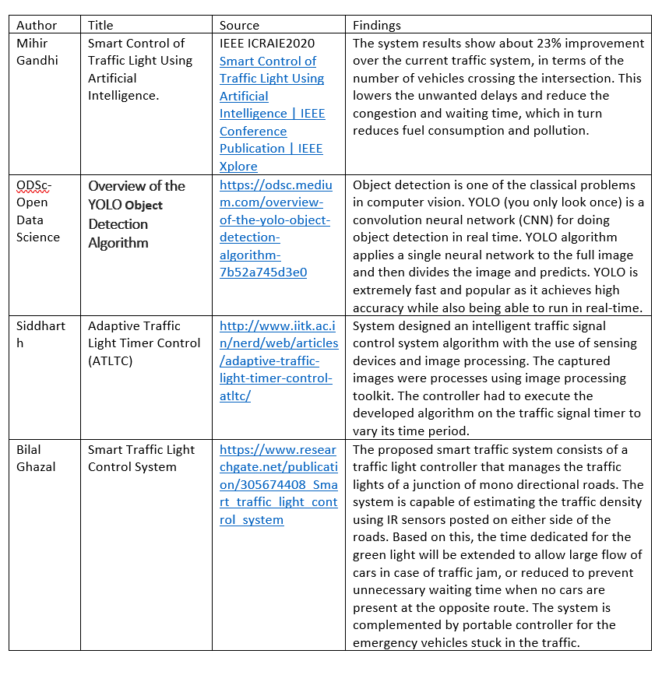

Table 2.1: Survey of Literature

**CHAPTER 3**

**Limitation of Existing system**

The prime concern of traffic control is to preserve time while still keeping people safe. Traditional systems are good; however, they are limited by the number of hours that humans can work. Human intervention is available to assist with critical decisions and emergencies. The traffic control officer pre-sets the timer settings based on a general survey of traffic patterns at a specific intersection. When a traffic density study was conducted, Bangalore came out to be among the worst in the world, with Mumbai coming in fourth place.

These are the three most widely used traffic management methods:

Manual Control: As the names suggest, this requires human input to control traffic. The traffic cop is assigned to a specific area and is in charge of traffic control. Police officers typically carry a signboard, a sign light, and a whistle.

Standard traffic signals: Signals are monitored by timers. The timer is set to a constant numeric value. The colors of the lights are auto linked with the timer values.

Electronic Sensors: One more advanced method is to deploy circuit detectors or proximity sensors on the streets. These sensos collect data about road traffic, and after that information is processed, the signal timer is set.

These traditional methods involve a significant amount of manpower for the manual controlling system. It is impossible to cover all areas of a city or town due to a lack of traffic police or police helpers.

The standard static traffic signal operates on a fixed timer for every phase and cannot adapt to real-time traffic density on the roads. When using electronic sensors, like proximity sensors or loop detectors, accuracy and coverage are commonly at odds because high-quality data collection is typically based on sophisticated and expensive technologies, and thus a limited budget will limit the number of facilities. Furthermore, due to the limited effective range of most sensors, total coverage on a network of facilities usually necessitates the use of multiple sensors [3].

**CHAPTER 4**

**Problem Statement, Objectives and Scope**

**4.1 Problem Statement**

To inaugurate a system which enhances the current traffic management by developing intelligent traffic lights based upon machine learning and artificial intelligence.

**4.2 Objectives**

The project aims to build a smart traffic lights system:

* To Detect vehicles - Using Machine Learning
* To Develop an Algorithm that

1. Controls the traffic lights according to the incoming traffic.

2. Has anti-honking module.

**4.3 Scope**

The basic idea of the project is to build a system to implement on traffic signals to make them smart.

Smart Signal system is divided into three modules:

1. Smart Traffic Controlling

This module is responsible for controlling traffic light timer according to the incoming traffic of vehicles in that lane.

1. Accident Detection Mechanism

This module detects the accident if any happens in the lane and send signal to respected authority.

1. Anti-honking system

This module is responsible for handling the noise pollution at the signal by making changes in the signal timer, every time the traffic exceeds certain decibel threshold, making traffic not honk unnecessarily.

**CHAPTER 5**

**Proposed System**

**5.1 Proposed system overview**

Video monitoring and surveillance systems have been widely used in traffic management in recent years for security, ramp metering, and providing real-time information and updates to travelers. Video monitoring systems can also be used to estimate traffic density and classify vehicles, which can then be used to control traffic signal timers to optimize traffic flow and reduce congestion. Our proposed system aims to create a computer vision-based traffic light controller that can adapt to the current traffic situation. It calculates real-time traffic density using live images from CCTV cameras at traffic intersections by detecting the number of vehicles at the signal and adjusting the green signal time accordingly. To obtain an accurate estimate of the green signal time, the vehicles are classified as a car, bike, bus/truck, or rickshaw. It employs YOLO to detect the number of vehicles and then sets the traffic signal timer based on vehicle density in the corresponding direction. This helps to optimize green signal times, and traffic is cleared at a much faster rate than a static system, reducing unwanted delays, congestion, and waiting time, and thus lowering fuel consumption and pollution.

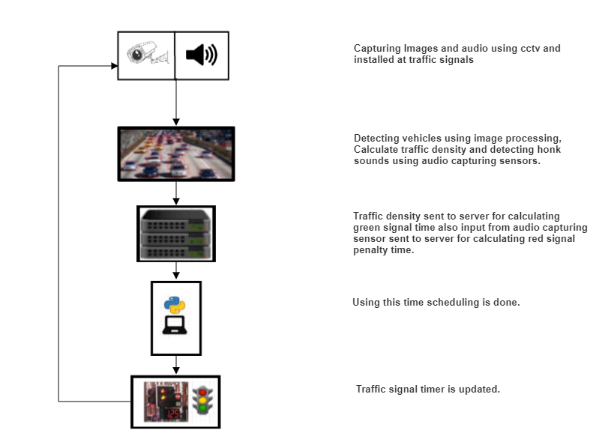

Figure 5.1.1: Architecture Diagram

Architecture Diagram

An architectural diagram is a visual representation that maps out the physical implementation for components of a software system. It shows the general structure of the software system and the associations, limitations, and boundaries between each element.

Firstly, CCTV/microphone captures data from the traffic signal in the form of images and sound and passes it on to the model. Further the collected data is processed into required format and decisions are calculated there based on the calculated density of traffic of vehicles. Timer is set and is then displayed on to the traffic signal.

Data Flow Diagram

A Data Flow Diagram (DFD) is a graphical representation of the “flow” of data through an information system (as shown on the DFD flow chart Fig.2 & Fig.3), modeling its process aspects. Often it is a preliminary step used to create an overview of the system that can later be elaborated.

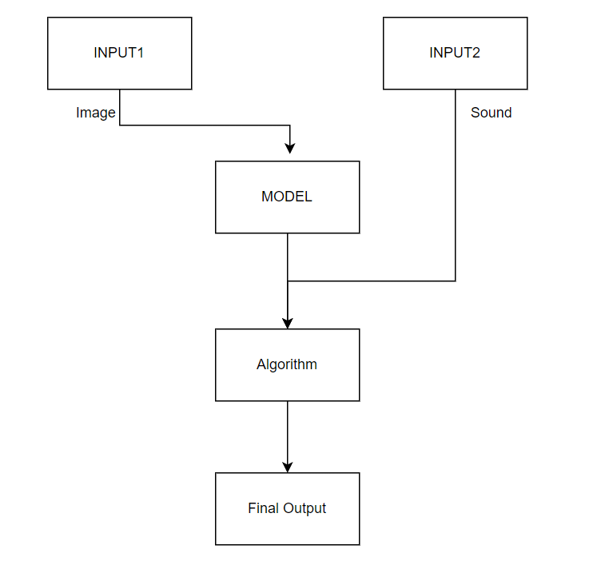

Figure 5.1.2: Data Flow Diagram (level 0)

Level-0

Data collected from components that is input1 and input2 are sent to Model, data calculated from there is sent to the algorithm for making decision and then considered as final output.

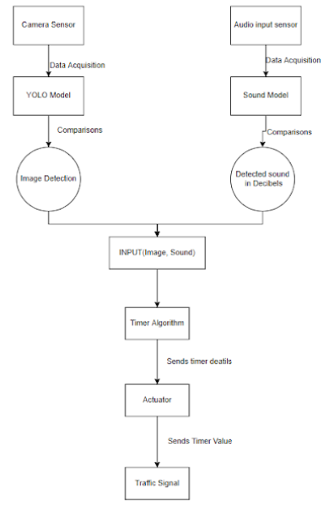

Figure 5.1.3: Data Flow Diagram (level 1)

Level-1

Data is collected from camera sensors in the form of images and from sound sensors in the form of audio. This data is then sent to YOLO model and Sound Model respectively. Image Detection and Sound detection is done and the data is then sent as input to Timer algorithm. Further actuators get the information and act according to the decision made and changes the signal light on the traffic signal.

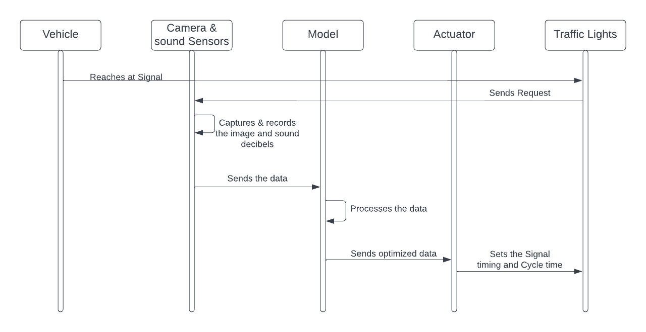

Figure 5.1.4: Sequence Diagram

Sequence Diagram

A sequence diagram is a Unified Modeling Language (UML) diagram that illustrates the sequence of messages between objects in an interaction. A sequence diagram consists of a group of objects that are represented by lifelines, and the messages that they exchange over time during the interaction.

Firstly, the vehicles reach the traffic signal, Sensors present on the signal are then sent requests for capturing the data. Camera and Audio sensor records the data. Data from there is sent to the Model, calculations are done on the data and a decision is taken. This decision data is sent to the actuators. On receiving the data from the model, actuators send the Signal and Cycle timing to the Signal and light timer changes accordingly.

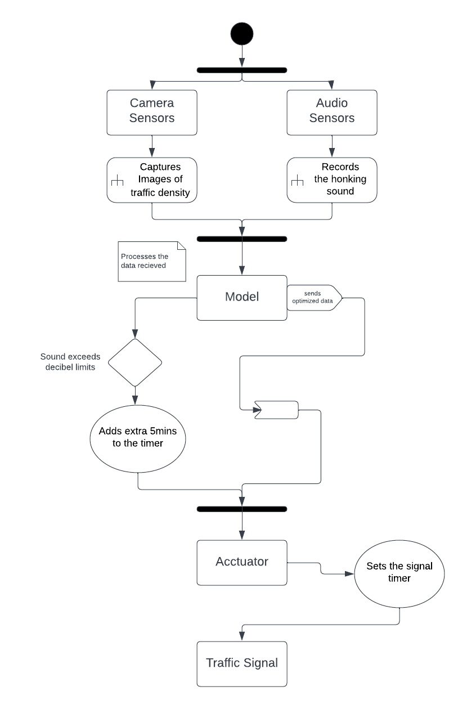

Figure 5.1.5: Activity Diagram

Activity Diagram

Activity diagram is basically a flowchart to represent the flow from one activity to another activity. The activity can be described as an operation of the system. The control flow is drawn from one operation to another. This flow can be sequential, branched, or concurrent.

Firstly, the capturing of data via the sensors takes place then the model comes into action and starts working. Calculation of timer is done. This decision is then sent at the signals where actuators perform timer displaying.

**5.2** **Design details**

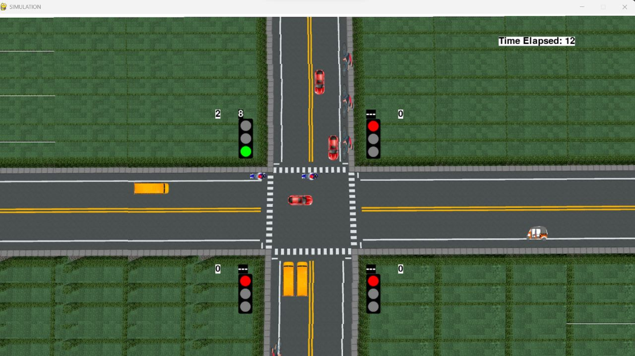

Figure 5.2.1: Implementation Output

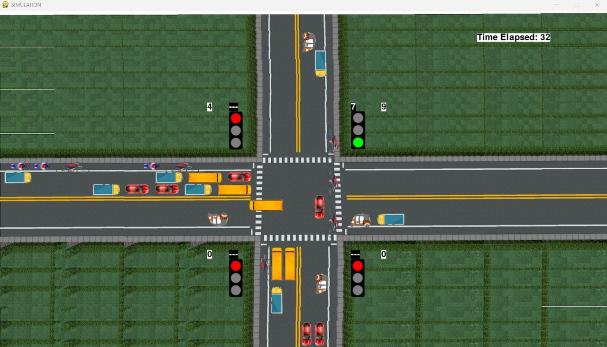Figure 5.2.2: Implementation Output

**5.3 Methodology**

The enhanced proposed system uses image processing and object detection to determine real-time traffic density using images from CCTV cameras at road intersections. The image is sent to the vehicle detection algorithm, which employs YOLO. The number of vehicles of each class, such as car, bike, bus, and truck, is counted in order to calculate traffic density. The signal switching algorithm, among other things, uses this density to set the green signal timer for each lane. The red signal times are updated as needed. In order to avoid lane starvation, the green signal time is limited to a maximum and minimum value. A simulation is also created to demonstrate the effectiveness of the system and compare it to the existing static system.

To simulate real-life traffic, a simulation was created from scratch using Pygame. It aids in visualizing and comparing the system to the existing static system. It has a four-way intersection with four traffic lights. On top of each signal is a timer that displays the amount of time until the signal changes from green to yellow, yellow to red, or red to green. Each signal also displays the number of vehicles that have passed through the intersection. Automobiles, bicycles, buses, trucks, and rickshaws arrive from all directions. Some of the vehicles in the rightmost lane turn to cross the intersection to make the simulation more realistic. It is also important to know whether a vehicle will turn or not.

Pygame is a cross-platform collection of Python modules for creating video games. It includes libraries for computer graphics and sound that are intended to be used with the Python programming language. Pygame extends the excellent SDL library with functionality. This enables users to create full-featured games and multimedia programs in Python. Pygame is extremely portable, running on almost every platform and operating system. It is free and open source under the LGPL license.

**CHAPTER 6**

**Experimental Setup**

**6.1 Software Requirements:**

* Python: Python is one of the widely used programming languages for building systems that indulge in Image Processing as well as Machine Learning. Python provides amazingly powerful libraries and tools that help us in achieving the tasks efficiently.
* OpenCV: It stands for Open-Source Computer Vision Library. This library consists of around 2000+ optimised algorithms that are useful for computer vision and machine learning. There are several ways you can use OpenCV in image processing like Conversion of images, Smoothening of images, etc.
* PyGame: A Python library used to create video animations or games. This includes several modules for playing sounds, drawing graphics, etc. It is also used to create client-side applications.
* NumPy: This is a library that lets one perform simple image techniques such as flipping images, extracting features and analysing them.
* Pandas: Pandas is an open-source library that is made mainly for working with relational or labelled data both easily and intuitively. It provides various data structures and operations for manipulating numerical data and time series. This library is built on top of the NumPy library.
* Windows 10 Operating System

**6.2 Hardware Requirements:**

* I3 processor
* 8 GB RAM
* 10Gb hdd free space

**CHAPTER 7**

**Project Plan**

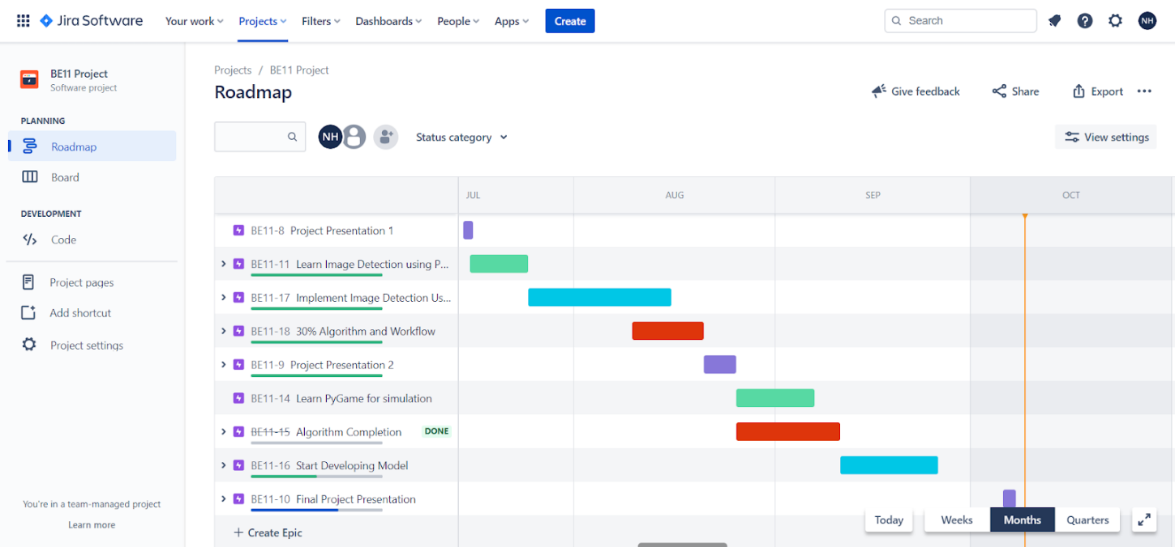

**CHAPTER 8**

**Expected Outcome**

Using modules such as Pygame, random, and math. Displaying a fully functional simulation of a scenario that includes a network of roads, traffic lights, and moving vehicles.

All five types of vehicles must be represented in the simulation, and they must be able to move in all directions regardless of which side they are approaching from. For example, a car approaching from one side of the road must be able to take any of the remaining straight, left, or right roads from the signal. Under no circumstances should the vehicles collide.

The vehicle traffic flow, or the number of vehicles coming from any given direction, must be generated.

Furthermore, the proposed system has some advantages over existing intelligent traffic control systems, such as Pressure Mats and Infrared Sensors. The cost of deploying the system is negligible because footage from CCTV cameras at traffic lights is used, which requires no additional hardware in most cases because intersections with heavy traffic already have such cameras. Only minor alignment may be required. Maintenance costs are also reduced when compared to other traffic monitoring systems, such as pressure mats, which normally suffer wear and tear due to their placement on roads where they are constantly subjected to immense pressure. As a result, the proposed system can be integrated with CCTV cameras in major cities to facilitate better surveillance.

**References**

1. M. M. Gandhi, D. S. Solanki, R. S. Daptardar and N. S. Baloorkar, "Smart Control of Traffic Light Using Artificial Intelligence," 2020 5th IEEE International Conference on Recent Advances and Innovations in Engineering (ICRAIE), 2020, pp. 1-6, doi: 10.1109/ICRAIE51050.2020.9358334.
2. Open Data Science, ‘Overview of the YOLO Object Detection Algorithm’, 2018. [Online]. Available:https://medium.com/@ODSC/overview-of-the-yolo-object-detection-algorithm-7b52a745d3e0.
3. Siddharth Srivastava, Subhadeep Chakraborty, Raj Kamal, Rahil, Minocha “Adaptive Traffic Light Timer Control (ATLTC)”, 29 March 2016, IIT Kanpur’s Nerd magazine.
4. TomTom.com, 'Tom Tom World Traffic Index', 2019. [Online]. Available: <https://www.tomtom.com/en_gb/traffic-index/ranking/>
5. Khushi, "Smart Control of Traffic Light System using Image Processing," 2017 International Conference on Current Trends in Computer, Electrical, Electronics and Communication (CTCEEC), Mysore, 2017, pp. 99-103, doi: 10.1109/CTCEEC.2017.8454966.
6. L. F. P. Oliveira, L. T. Manera, P. D. G. Luz, “Development of a Smart Traffic Light Control System With Real-Time Monitoring”, IEEE Internet of Things Journal ( Volume: 8, Issue: 5, 01 March 2021), DOI: 10.1109/JIOT.2020.3022392.
7. Bilal Ghazal, Khaled Chahine, Khalid Khabib, Mohamad Kherfan.”Smart Traffic Light Control System.”
8. Arif A. Bookseller, Rupali R Jagtap ‘Image processing based Adaptive Traffic Control System’, Second International Conference. on Emerging Trends in Engineering (SICETE), IOSR Journal of Electronics and Communication Engineering (IOSR-JECE) , PP: 33-37.
9. Rahishet, Aparajita Sahoo, Aparna Indore, Vaibhav Deshmukh, Pushpa U.S, Department of Electronics and Telecommunications Engineering, Fr. C Rodrigues Institute of Technology, Vashi “Intelligent Traffic Light Control Using Image Processing”, Proceedings of 21st IRF International Conference, Pune, India, ISBN: 978-93-82702-75-7, 8th March 2015.
10. Andrew P. Nichols ‘Adaptive Traffic Signal Control’ WVDOH/MPO/FHWA Planning Conference 10/3/2012.
11. Arif A. Bookseller, Rupali R Jagtap ‘Image processing based Adaptive Traffic Control System’, Second International Conference. on Emerging Trends in Engineering (SICETE), IOSR Journal of Electronics and Communication Engineering (IOSR-JECE) , PP: 33-37.
12. Emin Basic, Yasser De Jesus, Ashrafur Rahman ‘Adaptive Signal Control Technology: Current Practice and Comparison’, Intelligent Transportation Society of Connecticut, Student Research Project, Spring 2012.
13. Ovidiu Tomescu Ilona Madalina Moise, Alina Elena Stanciu, LulianBatros‘Adaptive Traffic Light Control System using Adhoc Vehicular Communication Networks’ U.P.B. Sci. Bull., Series D, Vol. 74, Iss. 2, 2012.